# Topic: Dijkstra's and Bellman Ford algorithms

**Objective:**

Implementing Dijkstra's and Bellman Ford algorithms.

**Problem Statement:**

Dijkstra algorithm is a single-source shortest path algorithm. Here, single-source means that only one source is given, and we have to find the shortest path from the source to all the nodes.

The Bellman–Ford algorithm is an [algorithm](https://en.wikipedia.org/wiki/Algorithm) that computes [shortest paths](https://en.wikipedia.org/wiki/Shortest_path) from a single source [vertex](https://en.wikipedia.org/wiki/Vertex_(graph_theory)) to all of the other vertices in a [weighted digraph](https://en.wikipedia.org/wiki/Weighted_digraph).[[1]](https://en.wikipedia.org/wiki/Bellman%E2%80%93Ford_algorithm#cite_note-Bang-1) It is slower than [Dijkstra's algorithm](https://en.wikipedia.org/wiki/Dijkstra%27s_algorithm) for the same problem, but more versatile, as it is capable of handling graphs in which some of the edge weights are negative numbers.

**Algorithm for Dijkstra’s :**

1. Mark the ending vertex with a distance of zero. Designate this vertex as current.

2. Find all vertices leading to the current vertex. Calculate their distances to the end. Since we already know the distance the current vertex is from the end, this will just require adding the most recent edge. Don’t record this distance if it is longer than a previously recorded distance.

3. Mark the current vertex as visited. We will never look at this vertex again.

4. Mark the vertex with the smallest distance as current, and repeat from step 2.

**Code:**

#include<stdio.h>

#include<conio.h>

#define INFINITY 9999

#define MAX 10

void dijkstra(int G[MAX][MAX],int n,int startnode);

int main()

{

int G[MAX][MAX],i,j,n,u;

printf("Enter no. of vertices:");

scanf("%d",&n);

printf("\nEnter the adjacency matrix:\n");

for(i=0;i<n;i++)

for(j=0;j<n;j++)

scanf("%d",&G[i][j]);

printf("\nEnter the starting node:");

scanf("%d",&u);

dijkstra(G,n,u);

return 0;

}

void dijkstra(int G[MAX][MAX],int n,int startnode)

{

int cost[MAX][MAX],distance[MAX],pred[MAX];

int visited[MAX],count,mindistance,nextnode,i,j;

//pred[] stores the predecessor of each node

//count gives the number of nodes seen so far

//create the cost matrix

for(i=0;i<n;i++)

for(j=0;j<n;j++)

if(G[i][j]==0)

cost[i][j]=INFINITY;

else

cost[i][j]=G[i][j];

//initialize pred[],distance[] and visited[]

for(i=0;i<n;i++)

{

distance[i]=cost[startnode][i];

pred[i]=startnode;

visited[i]=0;

}

distance[startnode]=0;

visited[startnode]=1;

count=1;

while(count<n-1)

{

mindistance=INFINITY;

//nextnode gives the node at minimum distance

for(i=0;i<n;i++)

if(distance[i]<mindistance&&!visited[i])

{

mindistance=distance[i];

nextnode=i;

}

//check if a better path exists through nextnode

visited[nextnode]=1;

for(i=0;i<n;i++)

if(!visited[i])

if(mindistance+cost[nextnode][i]<distance[i])

{

distance[i]=mindistance+cost[nextnode][i];

pred[i]=nextnode;

}

count++;

}

//print the path and distance of each node

for(i=0;i<n;i++)

if(i!=startnode)

{

printf("\nDistance of node%d=%d",i,distance[i]);

printf("\nPath=%d",i);

j=i;

do

{

j=pred[j];

printf("<-%d",j);

}while(j!=startnode);

}

}

OUTPUT:

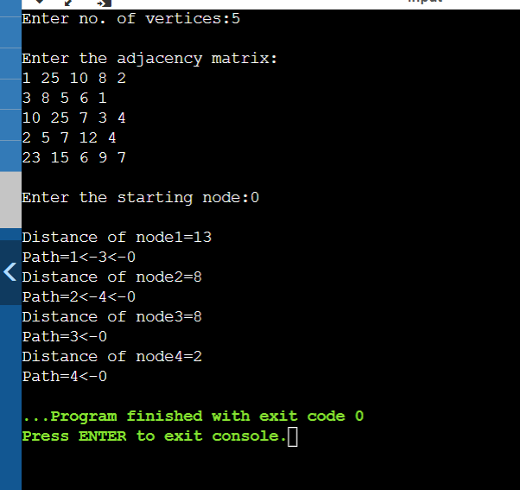

Here there are 5 vertices. Starting from node 0, the path is traversed. The first shortest distance path is from node 0 to node 1 which is 13. From node 0 to node 2 which is 8. From node 0 to node 3 which is 8. From node 0 to node 4 which is 2.

**Algorithm for Bellman Ford:**

Step 1: Make a list of all the graph's edges. This is simple if an adjacency list represents the graph.

Step 2: "V - 1" is used to calculate the number of iterations. Because the shortest distance to an edge can be adjusted V - 1 time at most, the number of iterations will increase the same number of vertices.

Step 3: Begin with an arbitrary vertex and a minimum distance of zero. Because you are exaggerating the actual distances, all other nodes should be assigned infinity.

For each edge u-v, relax the path lengths for the vertices:

If distance[v] is greater than distance[u] + edge weight uv, then

distance[v] = distance[u] + edge weight uv

Step 4:If the new distance is less than the previous one, update the distance for each Edge in each iteration. The distance to each node is the total distance from the starting node to this specific node.

Step 5: To ensure that all possible paths are considered, you must consider alliterations. You will end up with the shortest distance if you do this.

**Code:**

#include <stdio.h>

#include <stdlib.h>

#include <string.h>

#include <limits.h>

struct Edge

{

// This structure is equal to an edge. Edge contains two end points. These edges are directed edges so they

//contain source and destination and some weight. These 3 are elements in this structure

int source, destination, weight;

};

// a structure to represent a connected, directed and weighted graph

struct Graph

{

int V, E;

// V is number of vertices and E is number of edges

struct Edge* edge;

// This structure contain another structure which we already created edge.

};

struct Graph* createGraph(int V, int E)

{

struct Graph* graph = (struct Graph*) malloc( sizeof(struct Graph));

//Allocating space to structure graph

graph->V = V; //assigning values to structure elements that taken form user.

graph->E = E;

graph->edge = (struct Edge*) malloc( graph->E * sizeof( struct Edge ) );

//Creating "Edge" type structures inside "Graph" structure, the number of edge type structures are equal to number of edges

return graph;

}

void FinalSolution(int dist[], int n)

{

// This function prints the final solution

printf("\nVertex\tDistance from Source Vertex\n");

int i;

for (i = 0; i < n; ++i){

printf("%d \t\t %d\n", i, dist[i]);

}

}

void BellmanFord(struct Graph* graph, int source)

{

int V = graph->V;

int E = graph->E;

int StoreDistance[V];

int i,j;

// This is initial step that we know , we initialize all distance to infinity except source.

// We assign source distance as 0(zero)

for (i = 0; i < V; i++)

StoreDistance[i] = INT_MAX;

StoreDistance[source] = 0;

//The shortest path of graph that contain V vertices, never contain "V-1" edges. So we do here "V-1" relaxations

for (i = 1; i <= V-1; i++)

{

for (j = 0; j < E; j++)

{

int u = graph->edge[j].source;

int v = graph->edge[j].destination;

int weight = graph->edge[j].weight;

if (StoreDistance[u] + weight < StoreDistance[v])

StoreDistance[v] = StoreDistance[u] + weight;

}

}

// Actually upto now shortest path found. But BellmanFord checks for negative edge cycle. In this step we check for that

// shortest distances if graph doesn't contain negative weight cycle.

// If we get a shorter path, then there is a negative edge cycle.

for (i = 0; i < E; i++)

{

int u = graph->edge[i].source;

int v = graph->edge[i].destination;

int weight = graph->edge[i].weight;

if (StoreDistance[u] + weight < StoreDistance[v])

printf("This graph contains negative edge cycle\n");

}

FinalSolution(StoreDistance, V);

return;

}

int main()

{

int V,E,S; //V = no.of Vertices, E = no.of Edges, S is source vertex

printf("Enter number of vertices in graph\n");

scanf("%d",&V);

printf("Enter number of edges in graph\n");

scanf("%d",&E);

printf("Enter your source vertex number\n");

scanf("%d",&S);

struct Graph* graph = createGraph(V, E); //calling the function to allocate space to these many vertices and edges

int i;

for(i=0;i<E;i++){

printf("\nEnter edge %d properties Source, destination, weight respectively\n",i+1);

scanf("%d",&graph->edge[i].source);

scanf("%d",&graph->edge[i].destination);

scanf("%d",&graph->edge[i].weight);

}

BellmanFord(graph, S);

//passing created graph and source vertex to BellmanFord Algorithm function

return 0;

}

OUTPUT:

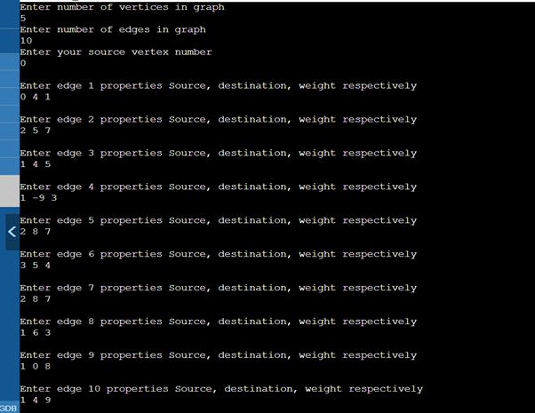

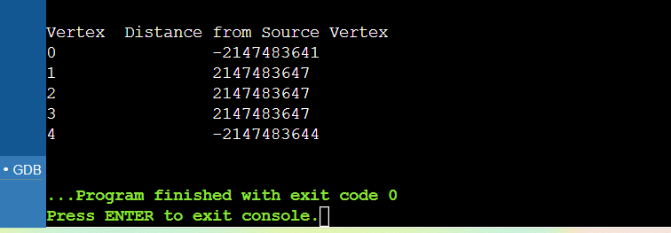

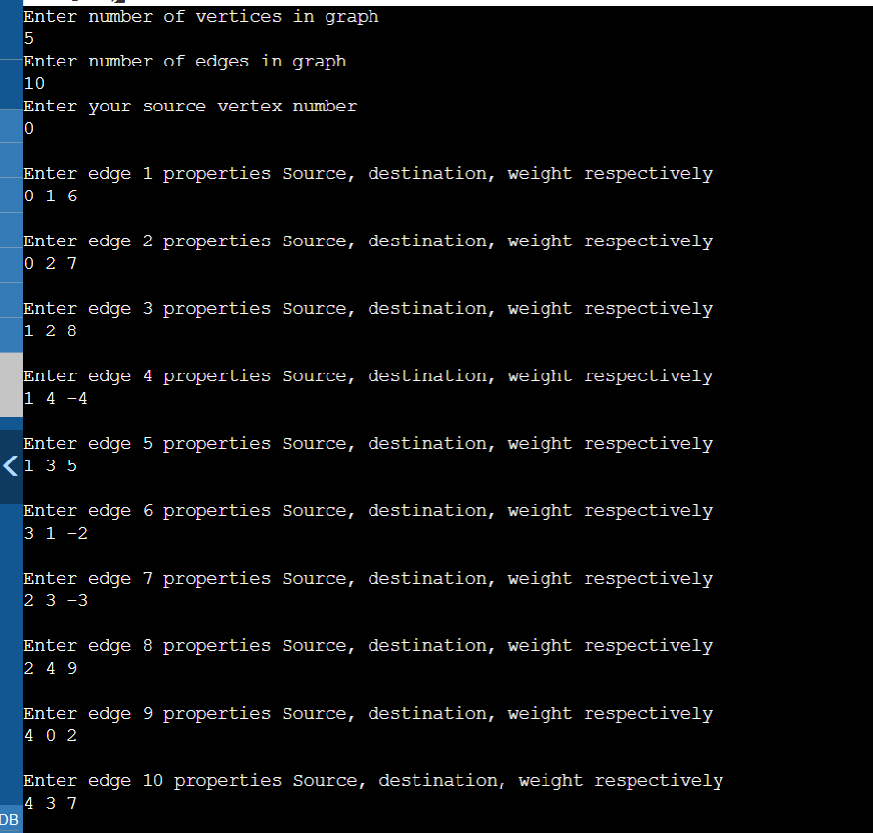

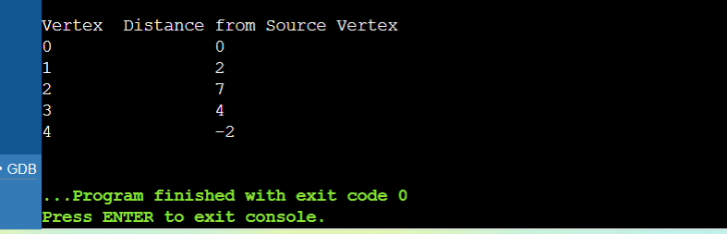

**Problems Faced:**

In this experiment, I didn’t face much problems. Because these algorithms are discussed in previous semesters, so it became easy to implement.

**Conclusion:**

With the help of this assignment, I understood the concept of Dijkstra's and Bellman Ford algorithms.

Bellman ford algorithm is a single-source shortest path algorithm. This algorithm is used to find the shortest distance from the single vertex to all the other vertices of a weighted graph. There are various other algorithms used to find the shortest path like Dijkstra algorithm, etc. If the weighted graph contains the negative weight values, then the Dijkstra algorithm does not confirm whether it produces the correct answer or not. In contrast to Dijkstra algorithm, bellman ford algorithm guarantees the correct answer even if the weighted graph contains the negative weight values.